Student’s name | …………………………………………………….…… | Grade | 7
Subject | Computer | Week No. | 9
Lesson Title | Cryptography | Unit
Worksheet No. ( 9 )
Question A: write the correct name of each part.

Decryption | Cipher Text | Algorithm | Plain Text

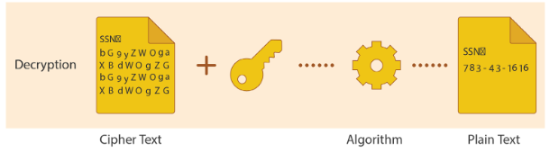
………..
………..
………..
Good Luck

